**PANTALLA EJECUTAR CON HISTÓRICO**

1. Probamos a procesar un fichero con 3 tablas con histórico. Se muestra la pantalla de selección de histórico y se marcan las tres tablas. Además, no se pueden marcar y desmarcar los check de histórico y vigente, que se debe.

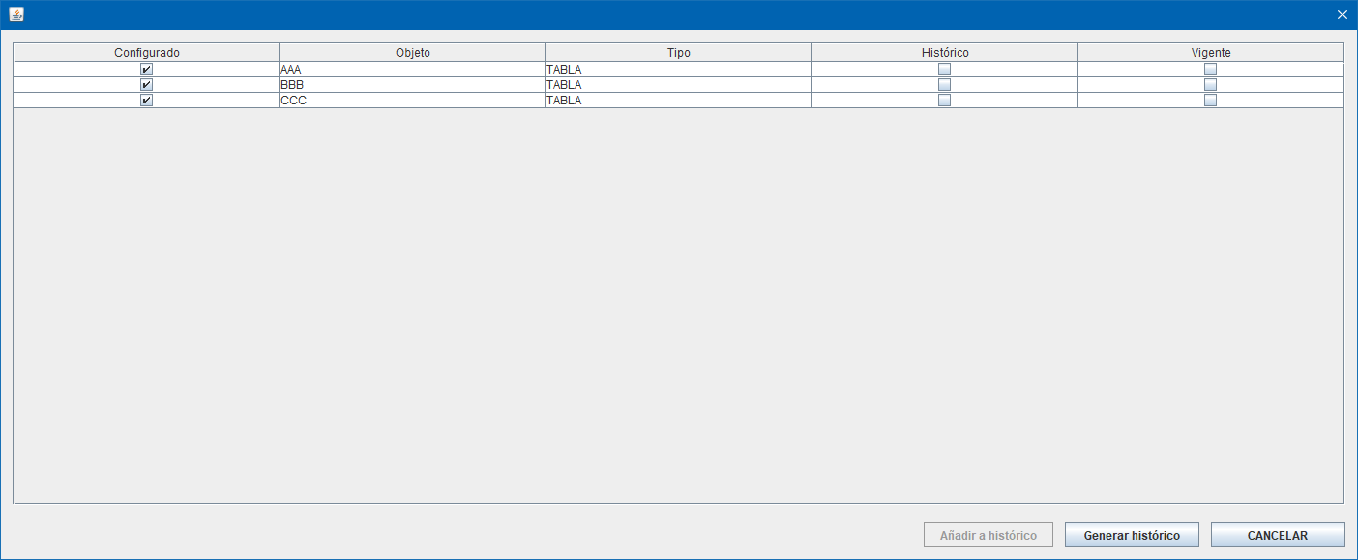

La información para rellenar esta pantalla se obtiene del procedimiento p_sel_histórico.

En la salida de p_sel_historico se distinguen bien los objetos (en este caso tablas, aunque para la parte visual es transparante de que tipo de objeto sea) existentes de las nuevas porque:

- Para las nuevas se devuelve mca_his = N (no configurada con histórico), y podrá marcarse para añadirla. **Estos registros inicialmente el check de configurado debe estar desmarcado**. Estos registros pueden marcar y desmarcar este check.

- Para las existentes con histórico se devuelve mca_his = S (y por tanto esas no se pueden desmarcar, son modificaciones de tablas que ya existen previamente y el sistema las tiene identificadas). Estos registros inicialmente el check de configurado debe estar marcado y **no se puede desmarcar**. En el documento se indica lo siguiente: “*Aquellos objetos que estén configurados con histórico no podrán desmarcar su check de Configurado de Histórico (aparecerá marcado y deshabilitado siempre).”*  Solo se deshabilita es check, el resto se puede marcar y desmarcar.

1. Además, inicialmente ningún objeto tiene marcado el Check de Vigente, cuando en el documento se especifica “*Por defecto todos los objetos tienen seleccionado el check de Vigente*”. Este check se puede marcar y desmarcar siempre.
2. En la pantalla faltan los 3 check de seleccionar todo.

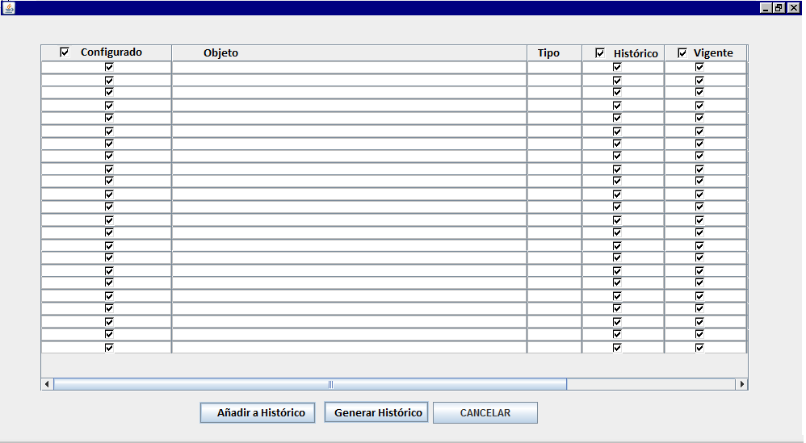

Importante aplicar la lógica de estos botones que pone en el documento. En concreto:

*En las columnas de Configurado, Histórico y Vigente habrá un Check para marcar o desmarcar todos.*

*- Check columna Configurado: Servirá para marcar todos los objetos. Si se desmarca, solo se desmarcan aquellos objetos que inicialmente no estuviesen ya configurados (los devueltos por el procedimiento p_sel_historico). Si todos los objetos del script ya están configurados con histórico, el check de la columna de configurado estará marcado, sin poder desmarcarse.*

*- Check columna Histórico: Servirá para marcar todos los objetos. Si se desmarca, solo se desmarcan aquellos objetos que inicialmente no estuviesen ya configurados (los devueltos por el procedimiento p_sel_historico).*

1. Se produce un error en el cmd. Creo que ha sido al cerrar la ventana de Selección de histórico:

MDSQL_T21AUTOS_EMISION

09:15:52.411 [AWT-EventQueue-0] INFO c.m.b.service.impl.ServiceSupport - {call SM2_K_LD_MDSQL_MARIPAM.P_SEL_HISTORICO(?,?,?,?,?)}

09:15:52.411 [AWT-EventQueue-0] INFO c.m.b.service.impl.ServiceSupport - Parßmetros de entrada:

[TextoLinea(valor=create table tron_ld.aaa (), TextoLinea(valor=a number);), TextoLinea(valor=comment on table tron_ld.aaa is 'tabla smd_ld.aaa';), TextoLinea(valor=comment on column tron_ld.aaa.a is 'columna a';), TextoLinea(valor=create table tron_ld.bbb (), TextoLinea(valor=b number);), TextoLinea(valor=comment on table tron_ld.bbb is 'tabla smd_ld.bbb';), TextoLinea(valor=comment on column tron_ld.bbb.b is 'columna b';), TextoLinea(valor=create table tron_ld.ccc (), TextoLinea(valor=c number);), TextoLinea(valor=comment on table tron_ld.ccc is 'tabla smd_ld.ccc';), TextoLinea(valor=comment on column tron_ld.ccc.c is 'columna c';)]

MDSQL_TRON21

Exception in thread "AWT-EventQueue-0" java.lang.NullPointerException

at com.mdsql.ui.listener.PantallaProcesarScriptActionListener.eventBtnProcesar(PantallaProcesarScriptActionListener.java:171)

at com.mdsql.ui.listener.PantallaProcesarScriptActionListener.actionPerformed(PantallaProcesarScriptActionListener.java:93)

at javax.swing.AbstractButton.fireActionPerformed(Unknown Source)

at javax.swing.AbstractButton$Handler.actionPerformed(Unknown Source)

at javax.swing.DefaultButtonModel.fireActionPerformed(Unknown Source)

at javax.swing.DefaultButtonModel.setPressed(Unknown Source)

at javax.swing.plaf.basic.BasicButtonListener.mouseReleased(Unknown Source)

at java.awt.Component.processMouseEvent(Unknown Source)

at javax.swing.JComponent.processMouseEvent(Unknown Source)

at java.awt.Component.processEvent(Unknown Source)

at java.awt.Container.processEvent(Unknown Source)

at java.awt.Component.dispatchEventImpl(Unknown Source)

at java.awt.Container.dispatchEventImpl(Unknown Source)

at java.awt.Component.dispatchEvent(Unknown Source)

at java.awt.LightweightDispatcher.retargetMouseEvent(Unknown Source)

at java.awt.LightweightDispatcher.processMouseEvent(Unknown Source)

at java.awt.LightweightDispatcher.dispatchEvent(Unknown Source)

at java.awt.Container.dispatchEventImpl(Unknown Source)

at java.awt.Window.dispatchEventImpl(Unknown Source)

at java.awt.Component.dispatchEvent(Unknown Source)

at java.awt.EventQueue.dispatchEventImpl(Unknown Source)

at java.awt.EventQueue.access$500(Unknown Source)

at java.awt.EventQueue$3.run(Unknown Source)

at java.awt.EventQueue$3.run(Unknown Source)

at java.security.AccessController.doPrivileged(Native Method)

at java.security.ProtectionDomain$JavaSecurityAccessImpl.doIntersectionPrivilege(Unknown Source)

at java.security.ProtectionDomain$JavaSecurityAccessImpl.doIntersectionPrivilege(Unknown Source)

at java.awt.EventQueue$4.run(Unknown Source)

at java.awt.EventQueue$4.run(Unknown Source)

at java.security.AccessController.doPrivileged(Native Method)

at java.security.ProtectionDomain$JavaSecurityAccessImpl.doIntersectionPrivilege(Unknown Source)

at java.awt.EventQueue.dispatchEvent(Unknown Source)

at java.awt.EventDispatchThread.pumpOneEventForFilters(Unknown Source)

at java.awt.EventDispatchThread.pumpEventsForFilter(Unknown Source)

at java.awt.EventDispatchThread.pumpEventsForFilter(Unknown Source)

at java.awt.WaitDispatchSupport$2.run(Unknown Source)

at java.awt.WaitDispatchSupport$4.run(Unknown Source)

at java.awt.WaitDispatchSupport$4.run(Unknown Source)

at java.security.AccessController.doPrivileged(Native Method)

at java.awt.WaitDispatchSupport.enter(Unknown Source)

at java.awt.Dialog.show(Unknown Source)

at java.awt.Component.show(Unknown Source)

at java.awt.Component.setVisible(Unknown Source)

at java.awt.Window.setVisible(Unknown Source)

at java.awt.Dialog.setVisible(Unknown Source)

at com.mdval.ui.utils.UIHelper.show(UIHelper.java:63)

at com.mdsql.ui.listener.FramePrincipalActionListener.evtProcesarScript(FramePrincipalActionListener.java:320)

at com.mdsql.ui.listener.FramePrincipalActionListener.actionPerformed(FramePrincipalActionListener.java:84)

at javax.swing.AbstractButton.fireActionPerformed(Unknown Source)

at javax.swing.AbstractButton$Handler.actionPerformed(Unknown Source)

at javax.swing.DefaultButtonModel.fireActionPerformed(Unknown Source)

at javax.swing.DefaultButtonModel.setPressed(Unknown Source)

at javax.swing.plaf.basic.BasicButtonListener.mouseReleased(Unknown Source)

at java.awt.AWTEventMulticaster.mouseReleased(Unknown Source)

at java.awt.Component.processMouseEvent(Unknown Source)

at javax.swing.JComponent.processMouseEvent(Unknown Source)

at java.awt.Component.processEvent(Unknown Source)

at java.awt.Container.processEvent(Unknown Source)

at java.awt.Component.dispatchEventImpl(Unknown Source)

at java.awt.Container.dispatchEventImpl(Unknown Source)

at java.awt.Component.dispatchEvent(Unknown Source)

at java.awt.LightweightDispatcher.retargetMouseEvent(Unknown Source)

at java.awt.LightweightDispatcher.processMouseEvent(Unknown Source)

at java.awt.LightweightDispatcher.dispatchEvent(Unknown Source)

at java.awt.Container.dispatchEventImpl(Unknown Source)

at java.awt.Window.dispatchEventImpl(Unknown Source)

at java.awt.Component.dispatchEvent(Unknown Source)

at java.awt.EventQueue.dispatchEventImpl(Unknown Source)

at java.awt.EventQueue.access$500(Unknown Source)

at java.awt.EventQueue$3.run(Unknown Source)

at java.awt.EventQueue$3.run(Unknown Source)

at java.security.AccessController.doPrivileged(Native Method)

at java.security.ProtectionDomain$JavaSecurityAccessImpl.doIntersectionPrivilege(Unknown Source)

at java.security.ProtectionDomain$JavaSecurityAccessImpl.doIntersectionPrivilege(Unknown Source)

at java.awt.EventQueue$4.run(Unknown Source)

at java.awt.EventQueue$4.run(Unknown Source)

at java.security.AccessController.doPrivileged(Native Method)

at java.security.ProtectionDomain$JavaSecurityAccessImpl.doIntersectionPrivilege(Unknown Source)

at java.awt.EventQueue.dispatchEvent(Unknown Source)

at java.awt.EventDispatchThread.pumpOneEventForFilters(Unknown Source)

at java.awt.EventDispatchThread.pumpEventsForFilter(Unknown Source)

at java.awt.EventDispatchThread.pumpEventsForHierarchy(Unknown Source)

at java.awt.EventDispatchThread.pumpEvents(Unknown Source)

at java.awt.EventDispatchThread.pumpEvents(Unknown Source)

at java.awt.EventDispatchThread.run(Unknown Source)